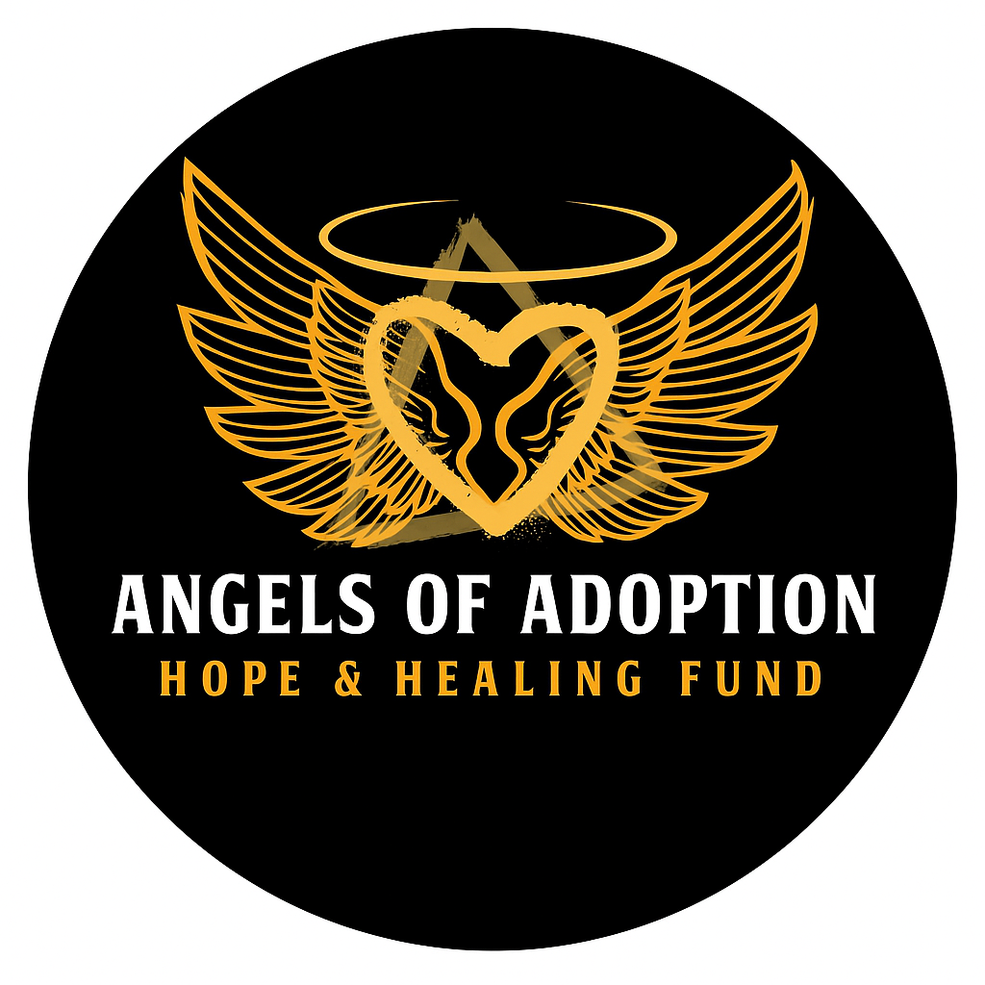

Nonprofit Application for Birth Mother Financial Assistance
Nonprofit agencies may use this form to request financial support for birth mothers facing pregnancy, adoption, or post-placement hardships. In the interest of privacy, please limit identifying information to the birth mother’s first name and general location. All information is handled with the utmost confidentiality and used solely for fund consideration purposes. Please direct all applications to aahopehealingfund@gmail.com
Section 1: Nonprofit Agency Information
Organization Name:
Executive Director Name:
Primary Contact Person:
Title/Role:
Phone Number:
Email Address:
Mailing Address:
Is your organization a 501(c)(3)? ☐ Yes ☐ No
Website:
Section 2: Expectant Mother or Birth Mother Information
First Name:
Age:
Location (City/State):
Current Status
☐ Expectant Parent – Currently navigating an adoption plan.
☐ Birth Parent – Have previously placed a child for adoption.
☐ Post-Placement – Seeking immediate or ongoing support services.
How long has the client been working with your nonprofit?
Does the client have safe housing today? ☐ Yes ☐ No
Section 3: Financial Need Summary
Please provide a brief overview of the birth mother’s current financial status and the primary motivation for this application. Include details regarding income sources, existing support systems, personal strengths, and any significant environmental stressors.
Estimated Monthly Income: $
Estimated Monthly Expenses: $
Other sources of assistance or support (if applicable):
Section 4: Requested Assistance
☐ Postpartum & Medical Recovery
☐ Education & Career Development
☐ Mental Health & Grief Counseling
☐ Housing & Basic Needs Stability
☐ Parenting Support (for Birth Mothers with Other Children)
☐ Adoption-Related Healing & Connection
☐ Relapse Prevention & Recovery Support
☐ Long-Term Empowerment & Self-Sufficiency
☐ Other:
Amount requested $
Intended use of funds:
Section 5: Agency Statement
We invite you to share a summary detailing the birth mother’s situation and the anticipated impact of this funding. Please clarify how these resources will facilitate her stability and well-being throughout her adoption journey. To maintain confidentiality, please omit full identifying details; supporting documentation may be attached separately.
Section 6: Authorization and Signature
I hereby certify that all information provided in this application is true, complete, and accurate to the best of my knowledge.
Authorized Agency Representative Name:
Title:
Signature:
Date:
Please direct all applications to aahopehealingfund@gmail.com

For Office Use Only
Date Received:
Reviewed By:
Approved: ☐ Yes ☐ No
Amount Approved: $
Notes:

Board/Reviewer Scoring Sheet
Applicant Organization:

Client’s First Name:
Category Scoring
1 (low) – 5 (high)
Urgency of Need: 1 2 3 4 5

Impact on Stability & Healing: 1 2 3 4 5

Clarity of Request: 1 2 3 4 5
Appropriate Use of Funds: 1 2 3 4 5

Other Supports in Place: 1 2 3 4 5
Funding Recommendation: ☐ Approve ☐ Deny ☐ Table
Amount Approved: $

Reviewer Notes:

