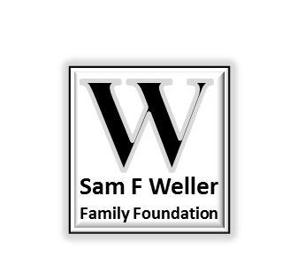

**Grant Evaluation Report (type-in Word document available at website**

[www.SamFWellerFamilyFoundation.org](http://www.SamFWellerFamilyFoundation.org) **)**

**Instructions:**

Evaluation is an integral part of the grant process; it is necessary for our records and will assist us in project assessment and future grant awards. As part of your grant award, the Sam F Weller Family Foundation requests that you ***complete and return this document to the Board following your grant-project completion date, or within 90 days of the grant date, whichever comes first*** (if the project is not completed within 90 days, please submit this as a progress report).

**Contact Information:**

|  |  |  |
| --- | --- | --- |
| Grant Date: | Evaluation Date: | |
| Organization Name: | | |
| Address: | | |
| Contact Person Name: | | Phone: |
| Contact Email: | | |

**Narrative: (attach pictures, marketing materials, or documentation of the project, as appropriate)**

Describe the project or event supported by the grant funds including population and number served, activities completed, supplies/equipment purchased, or staff involved, and any other information you feel would be useful for the SFWFF board to know about your project.

Describe how this grant helped to meet your project goals, and what difference it made to your targeted population. List any unanticipated benefits or challenges encountered with your project.