Beresford Area Foundation:
Grant Funding Community Impact Report

BERESFORD AREA FOUNDATION

The Beresford Area Foundation is managed by a local board of volunteers who believe in building long-term assets for the community. We believe in giving grants to nonprofits making Beresford a better place to live, work, and enjoy.

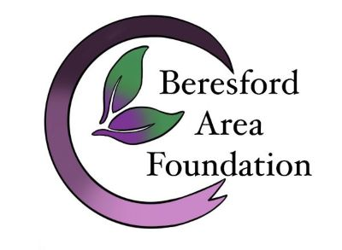Completion of this brief form by each grant recipient is a prerequisite for consideration for any future BAF grants! Due Date: February 1st following the grant year.

Grant Recipient: (organization’s name)

Grant Coordinator/Applicant: Grant Coordinator Phone #:

Grant Amount Awarded: $

Grant Request Purpose, Program or Project:
Grant Use of Funds Report: Please provide a detailed budget report/breakdown of how BAF funds were specifically used.

Grant Outcomes & Beresford Community Impact: Please provide a brief summary of the measurable outcomes and impact on the Beresford community achieved through the grant purpose. Please include statistics (i.e. the estimated # of people impacted) and the targeted population served.

Additional Comments:

Special Information: Please attach any posters, publicity, or media for this grant. Photos of completed project are welcomed.

Thank you very much for your feedback. This is very important to our Foundation.
OPTIONS TO SUBMIT YOUR COMMUNITY IMPACT REPORT:
a. Email: Community Impact Report and additional materials to: mjmc073154@gmail.comt
b. Mail: Community Impact Report and additional materials to: Beresford Area Foundation, PO Box 84, Beresford, SD 57004

